**HOSTING A STATIC WEBSITE ON AMAZON S3(SIMPLE STORAGE SERVICE)**

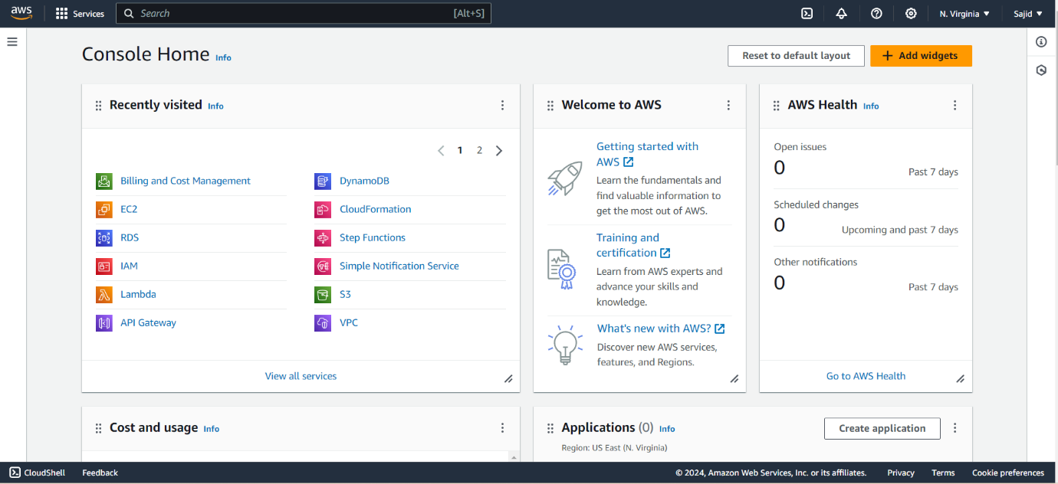-Sign in to the AWS Management console. After sign in, the screen appears is shown below:

-Then move to the S3 services, which appears in console home. After clicking on S3, the screen appears is shown below:

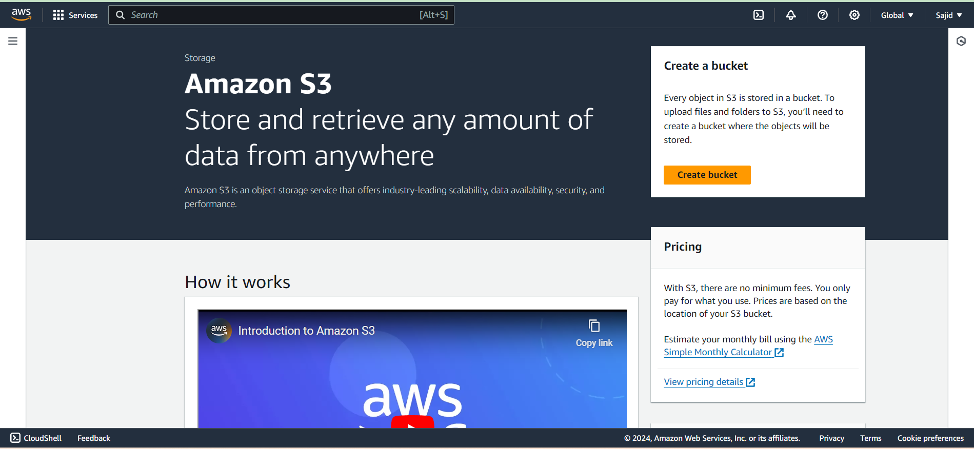

-Next to create an S3 bucket, click on the "Create bucket". On clicking the "Create bucket" button, the screen appears is shown below:

-Enter the bucket name which should look like DNS address, and it should be resolvable. A bucket is like a folder that stores the objects. A bucket name should be unique. A bucket name should start with the lowercase letter, must not contain any invalid characters. It should be 3 to 63 characters long(www.saitharuns3.com).

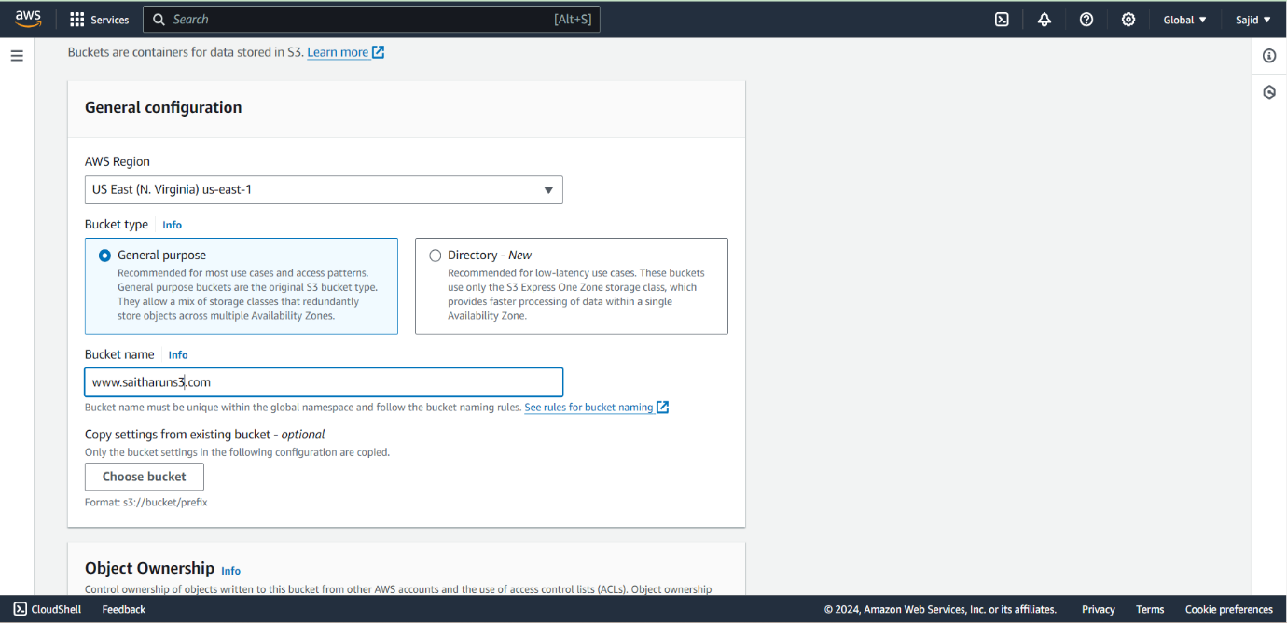-Next, choose an AWS region nearest to your location or where you want your data to reside. In our case, it is (US East [N. Virginia]us-east-1).

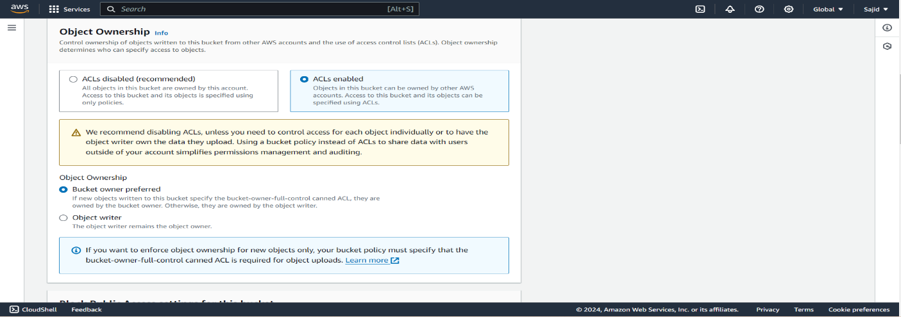-Scroll down and then the Object Ownership category, we use it for controlling the access of the files by specifying roles. If ACLs are disabled, the bucket owner automatically owns and has full control over every object in the bucket. If ACLs are enabled, the bucket owner can be owned by the other AWS accounts, access to the bucket and its objects can be specified using ACLs. So, select as ACLs enabled.

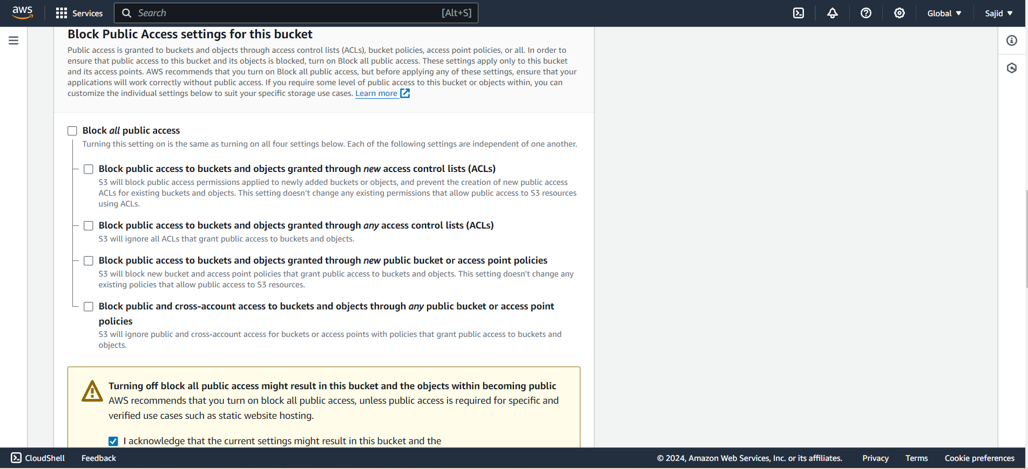-Next in Block Public Access settings for this bucket category, ensure that BLOCK ALL PUBLIC ACCESS has been checked. If you want to host your static website in this bucket, you can change the settings later. So, unmark the ALL PUBLIC ACCESS and mark the acknowledge settings.

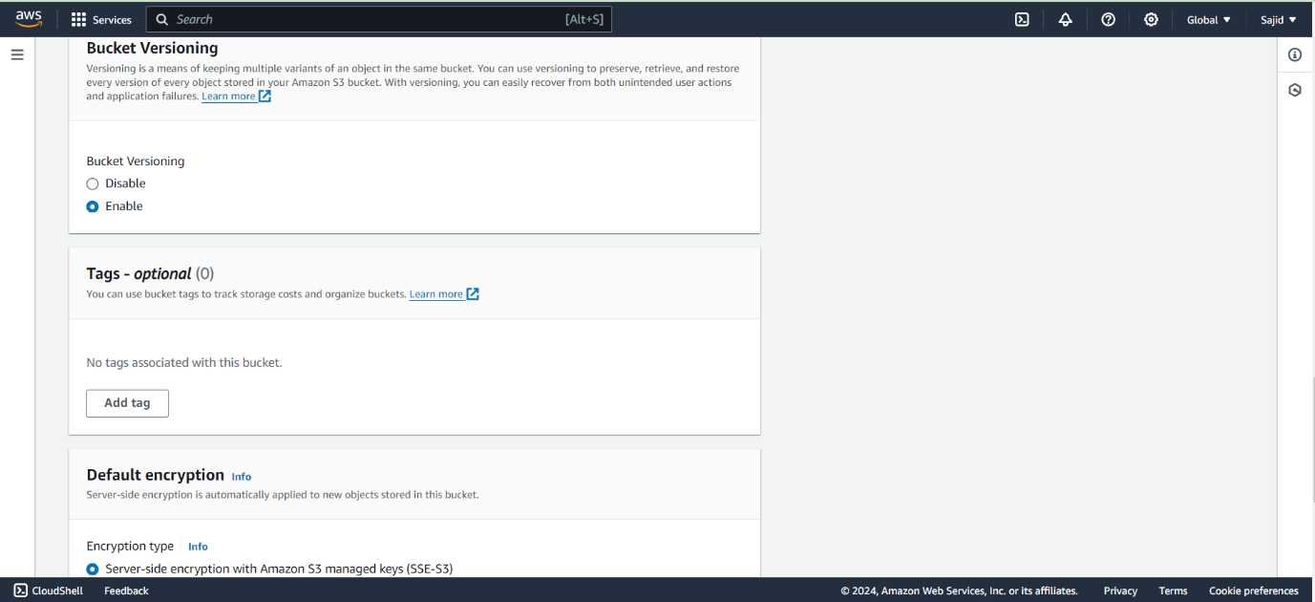-Next the Bucket Versioning category, choose Enabled. Bucket versioning is helpful when you want to track any changes in the file made, intentionally or unintentionally. You can see the previous versions of a file, retrieve it, restore it or preserve it.

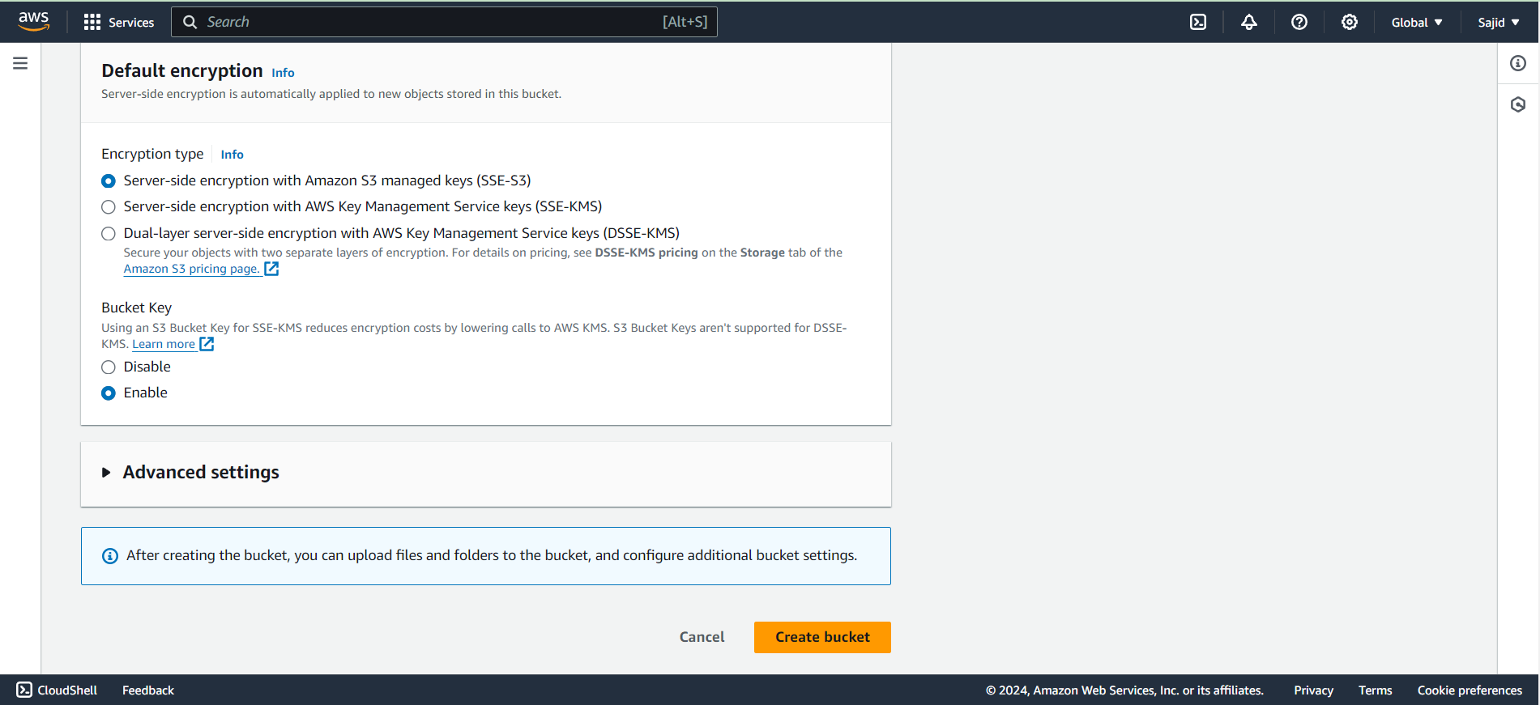-Leave other advance settings as default.

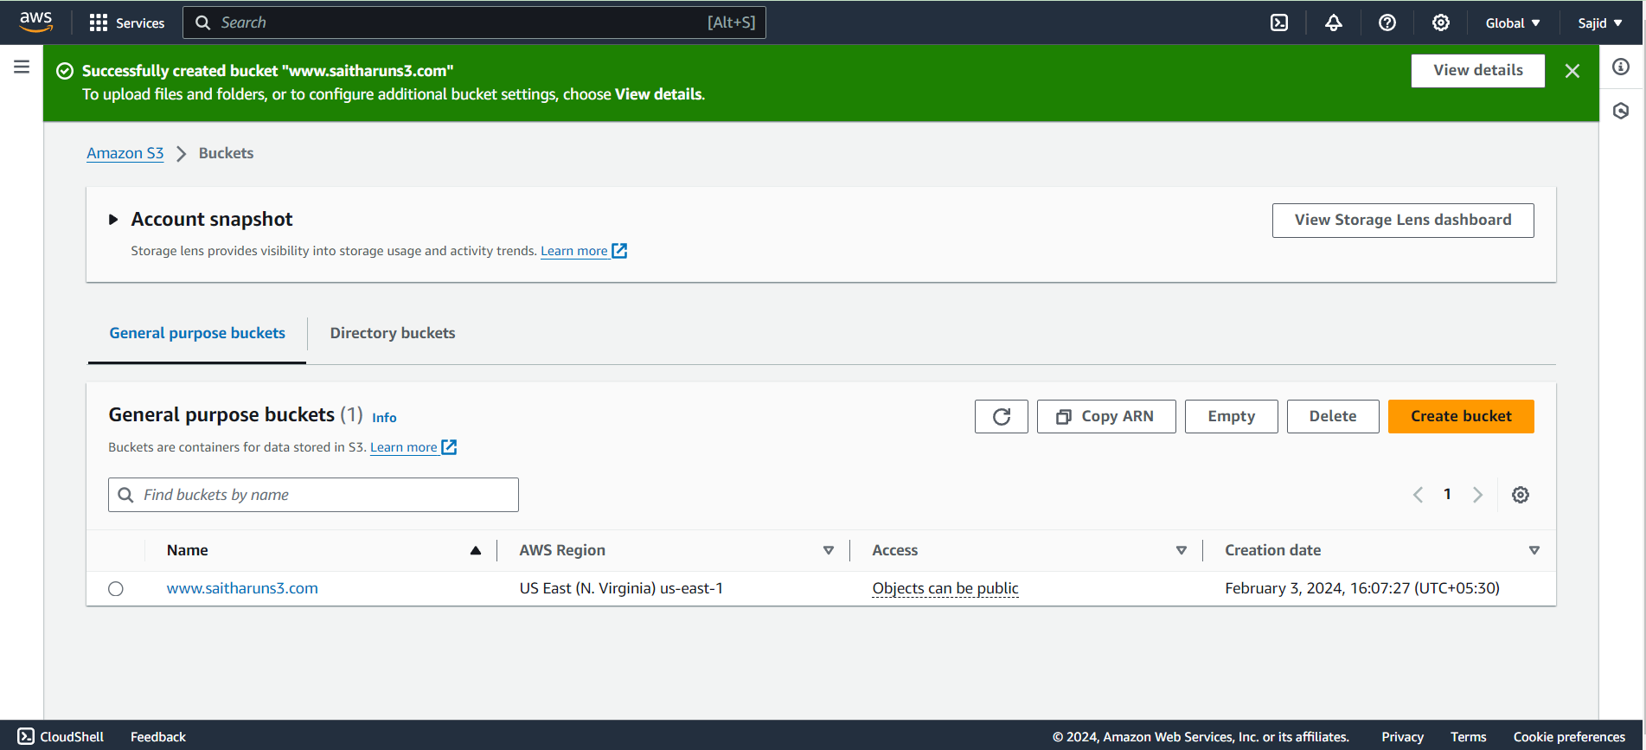-Click on the "Create" button. Now, the bucket is created.

-Now, click on the "www.saitharuns3.com" to upload a file in this bucket.

-Click on the "Upload" button to add the files to your bucket.

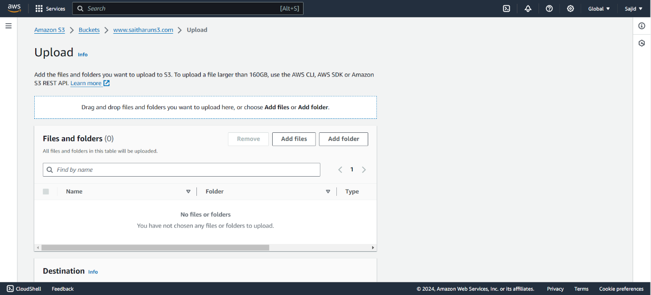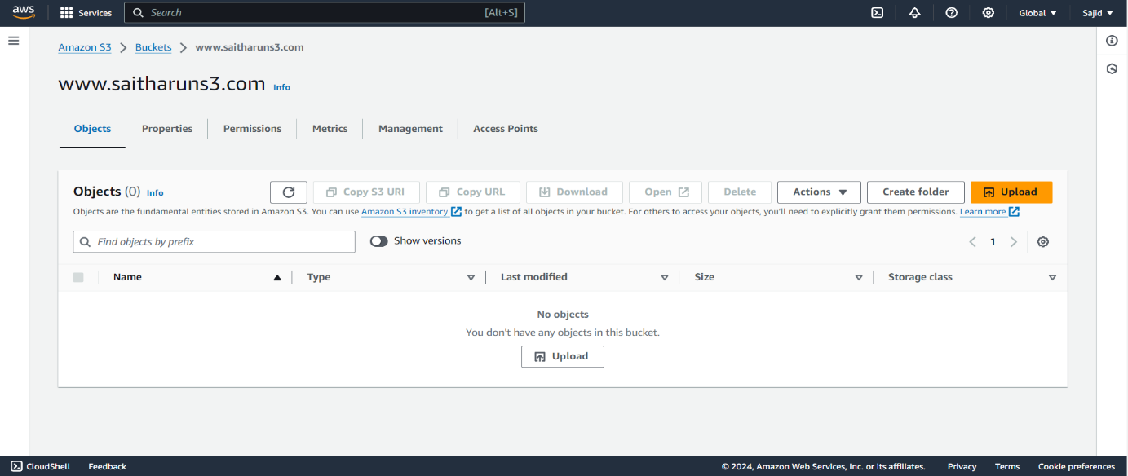-Click on the "Add files" button.

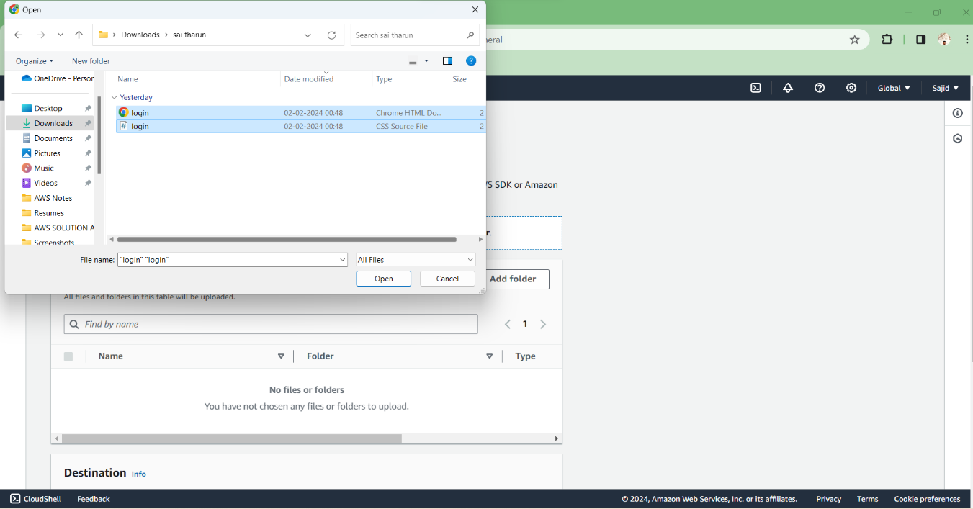-Add the file.

-After adding the file Grant the public-read access for anyone will be able to access the specified objects and also the object owner will have read and write access.

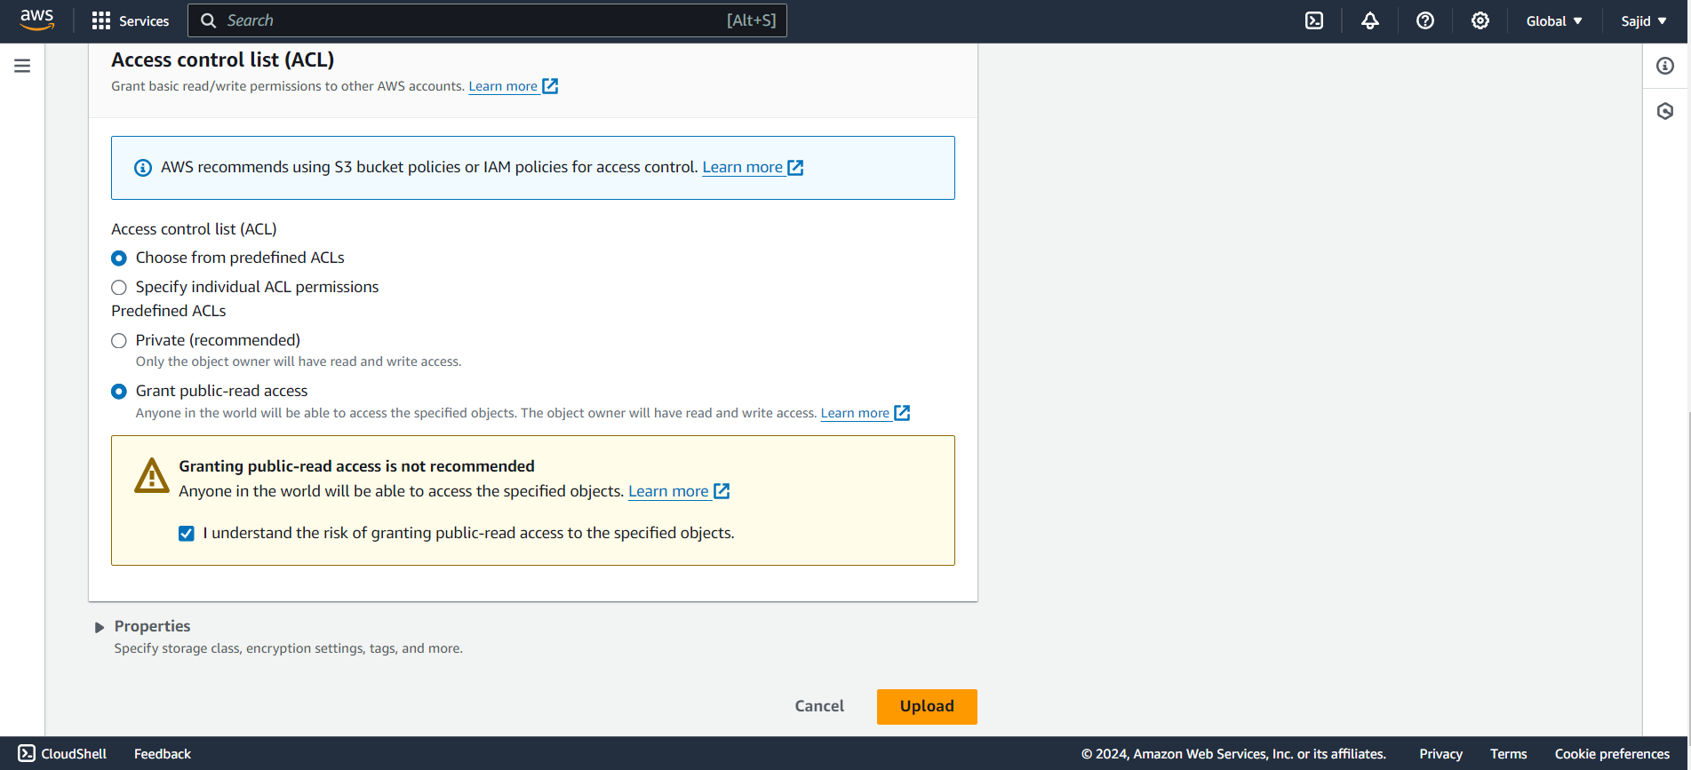-Click on UPLOAD button.

-From the above screen, we observe that the "login.html" has been successfully uploaded to the bucket "www.saitharuns3.com".

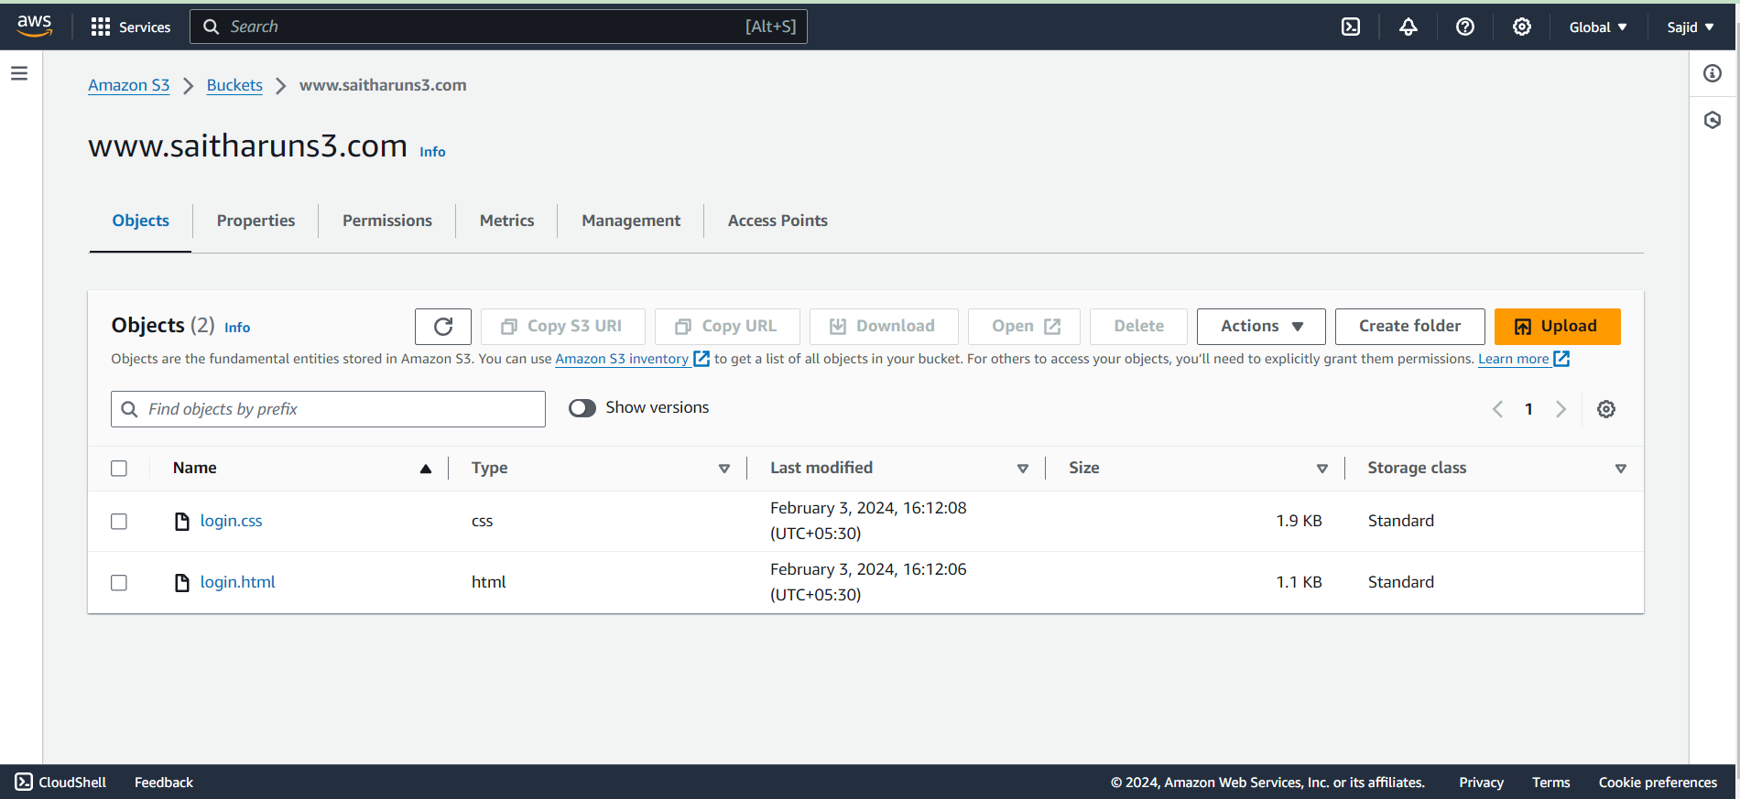

-Click on the “Actions” and then Click on “Make Public using ACL”.

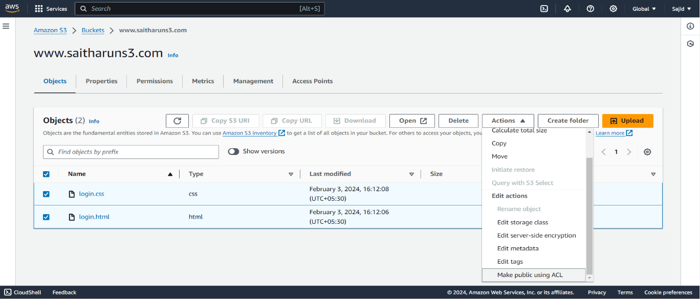

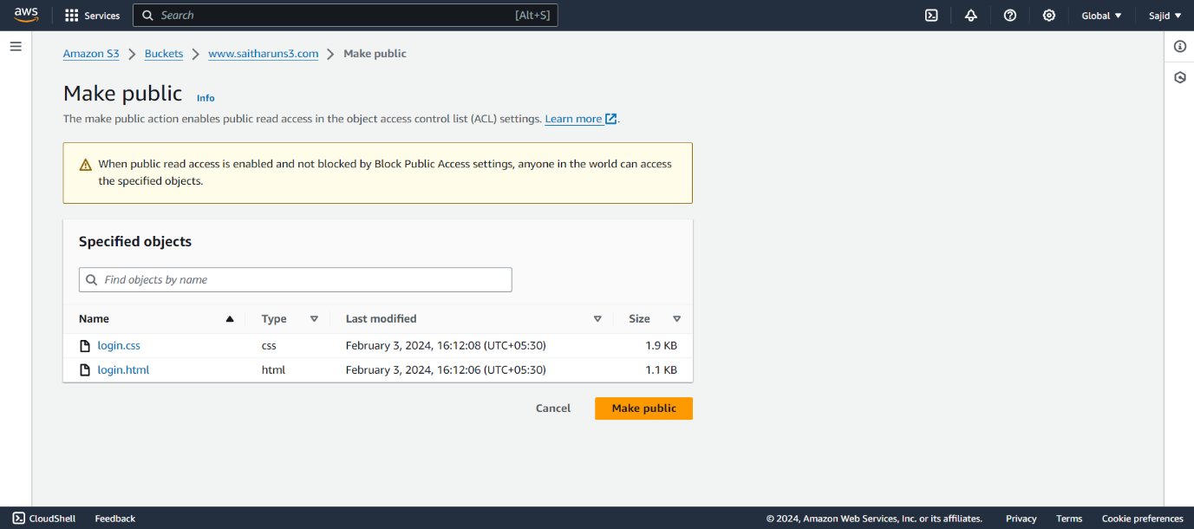-Then click on make public to give access to all.

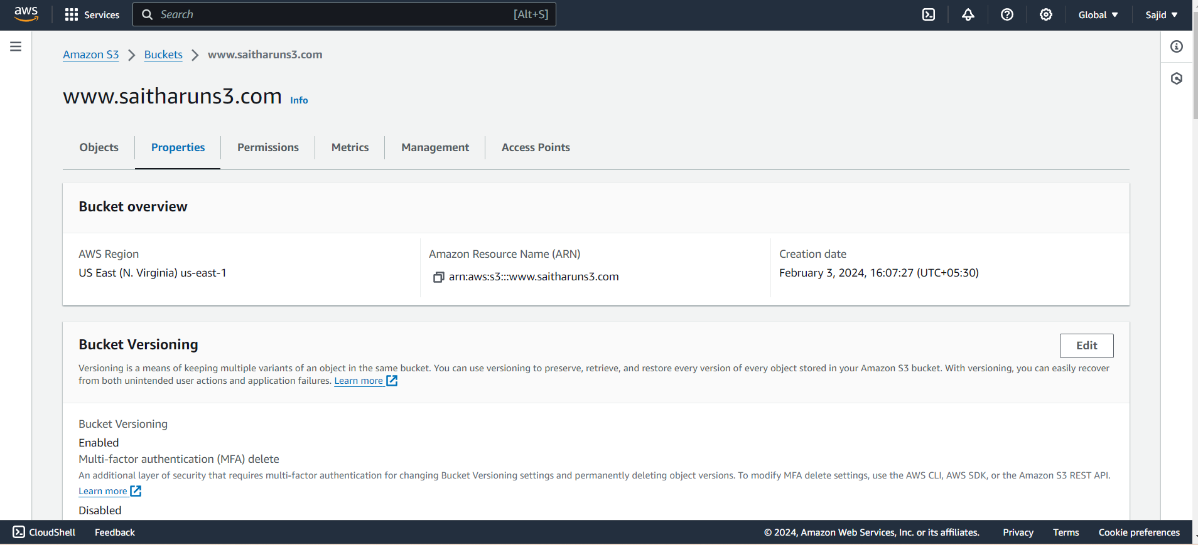-Move to the Properties scroll down to Enable the Static Website Hosting.

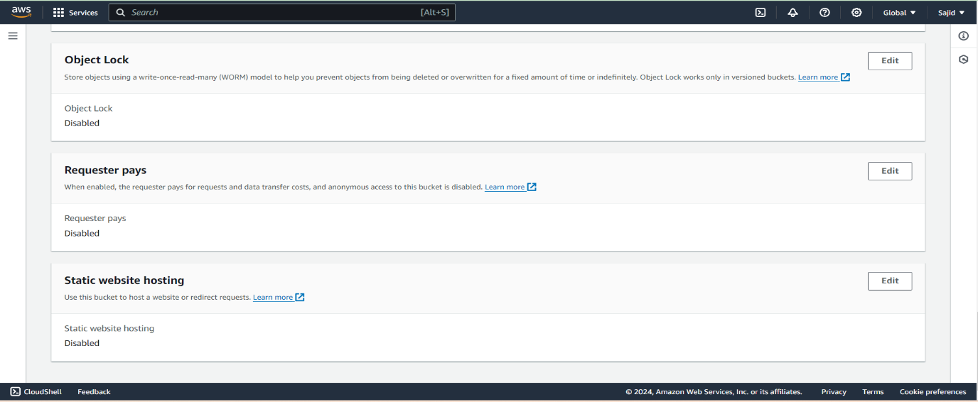-Click on Edit to enable the static website hosting.

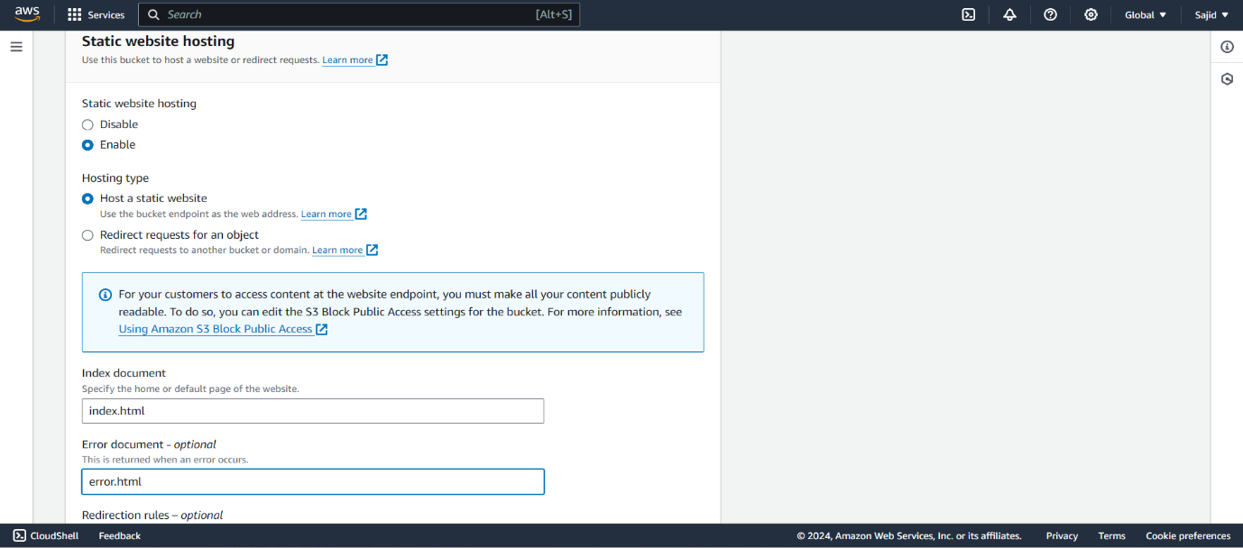-Enable the static website hosting and leave the changes by default settings give the document name as “index.html”.

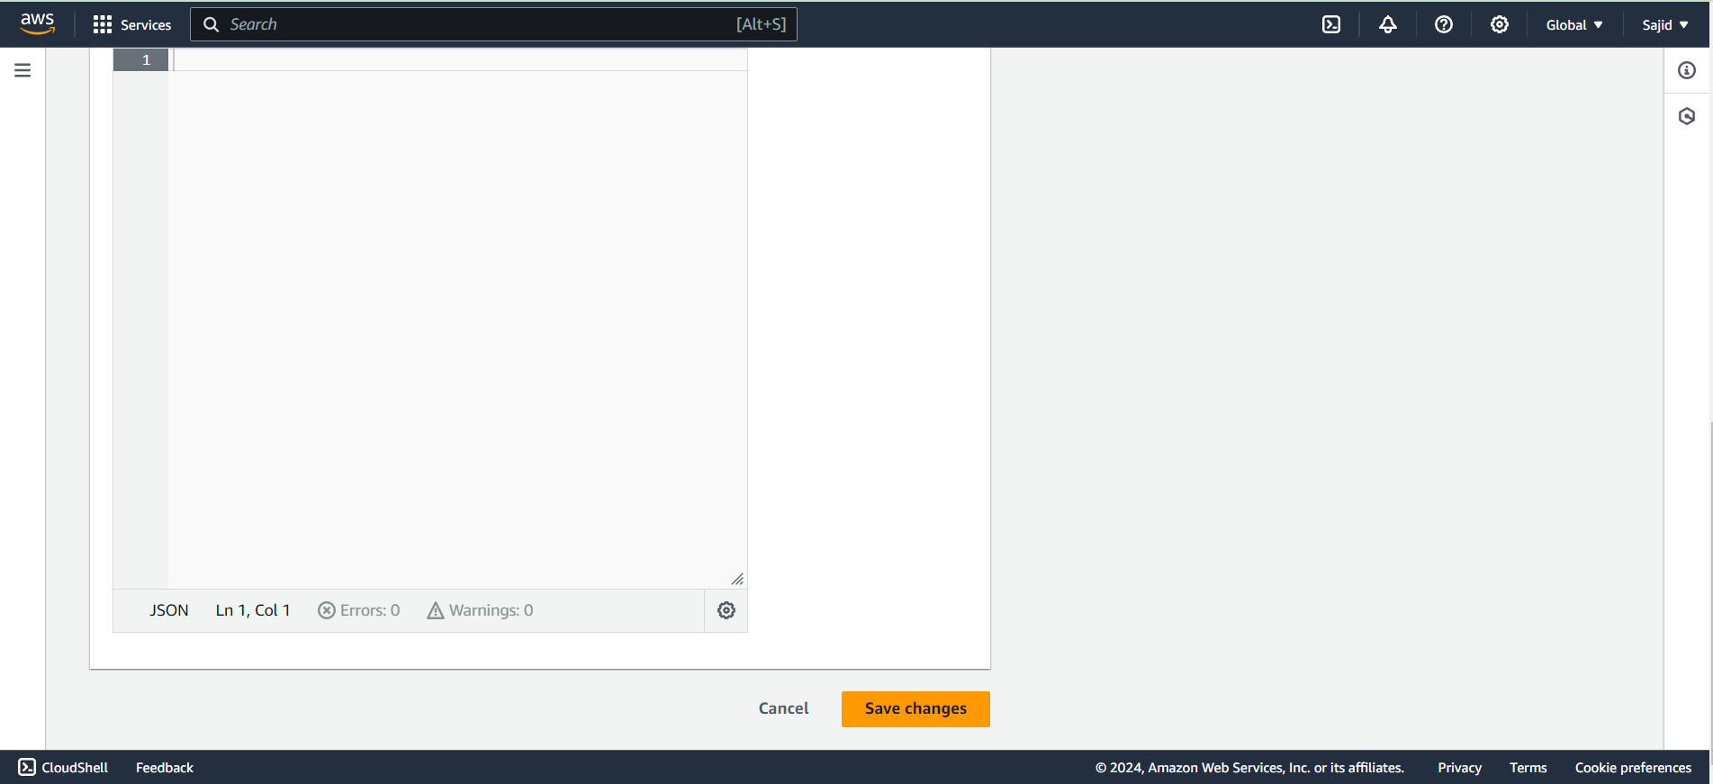-Then click on Save Changes.

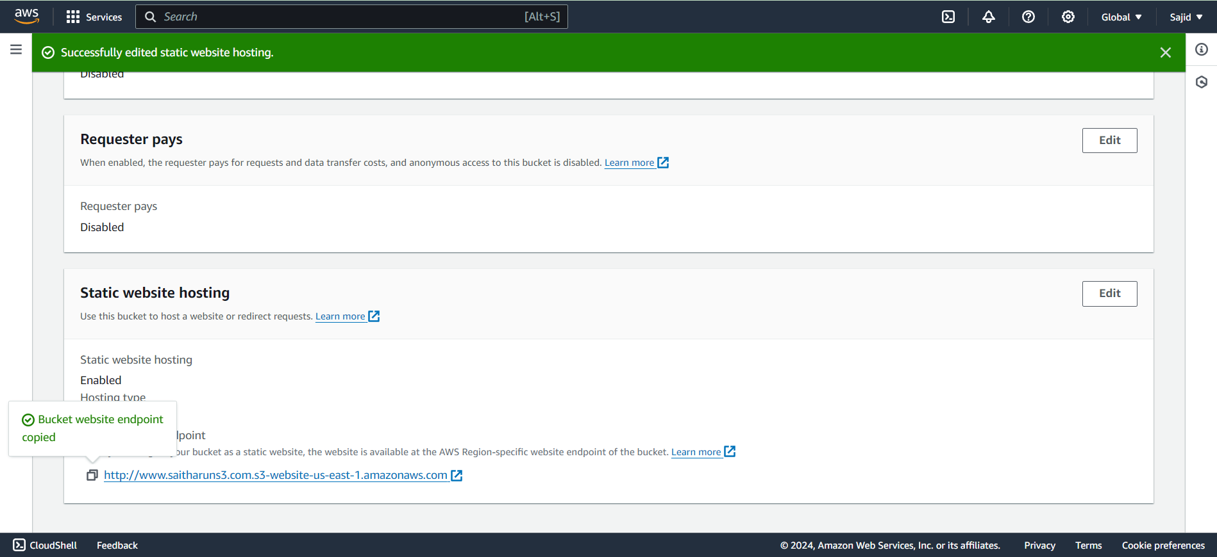-Copy the Bucket website Endpoint and open the new tab to paste the URL.

-Then the file will run by in the New Tab by making the public access and enabling the static website hosting.

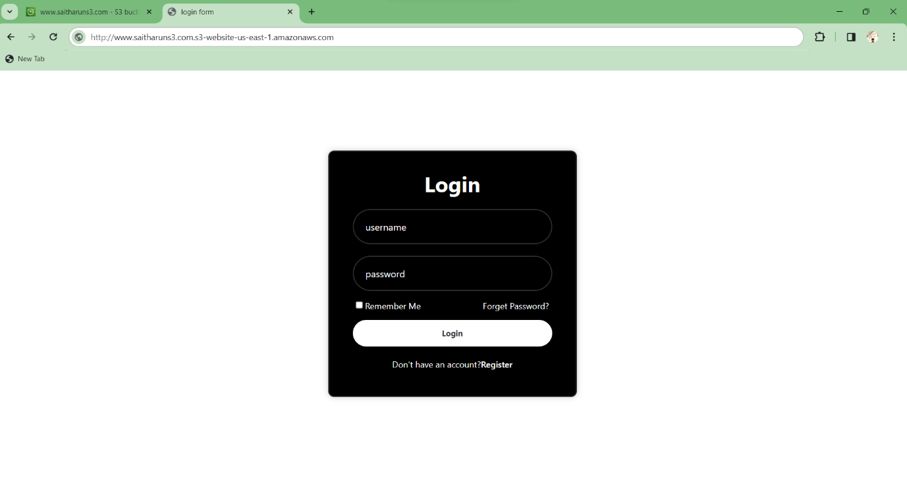-Then the website will host successfully on Amazon S3.

**V SAI THARUN GOUD**